STEPS FOR LAMP (Linux, Apache, MySql and PHP) STACK INSTALLATION AND TEST

Launched an AWS EC2 Ubuntu instance and ssh into it using my key and DNS crendentials

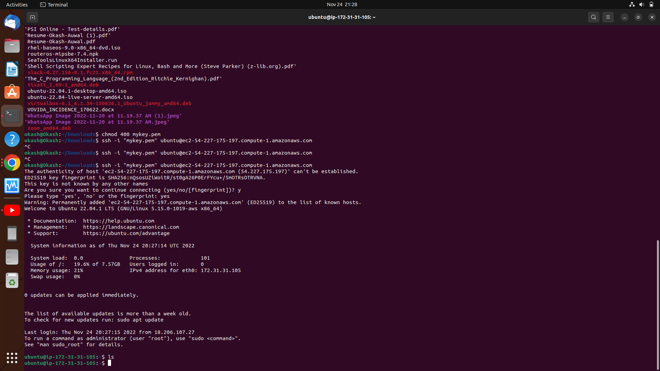
Installed the apache web server and confirmed it was running using the systemctl command

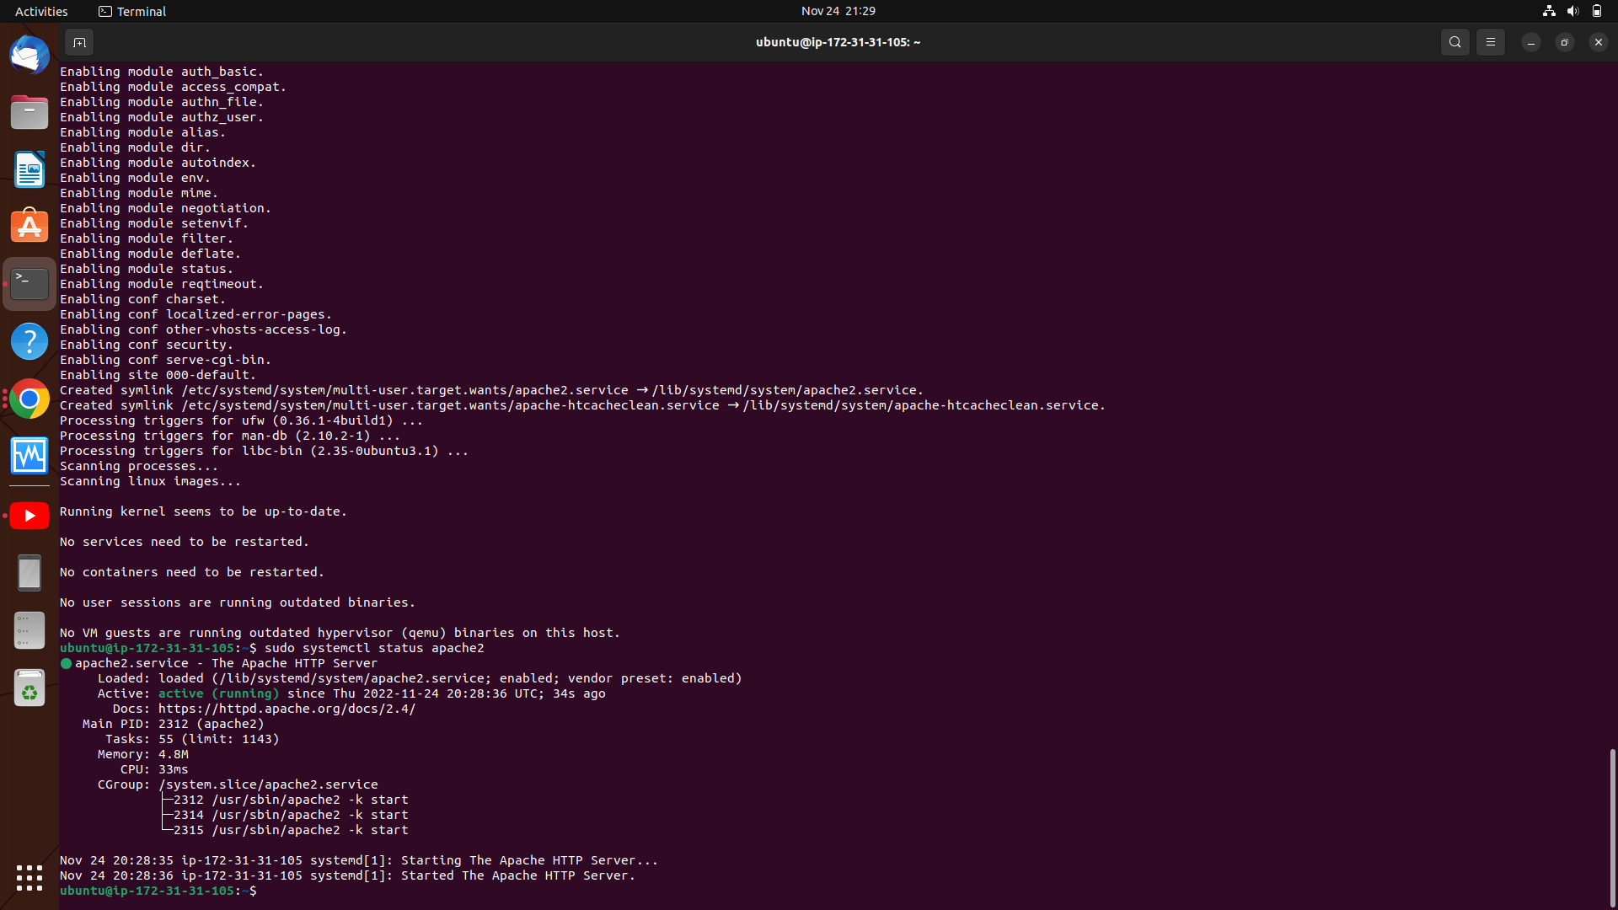

And then installed the mysql database

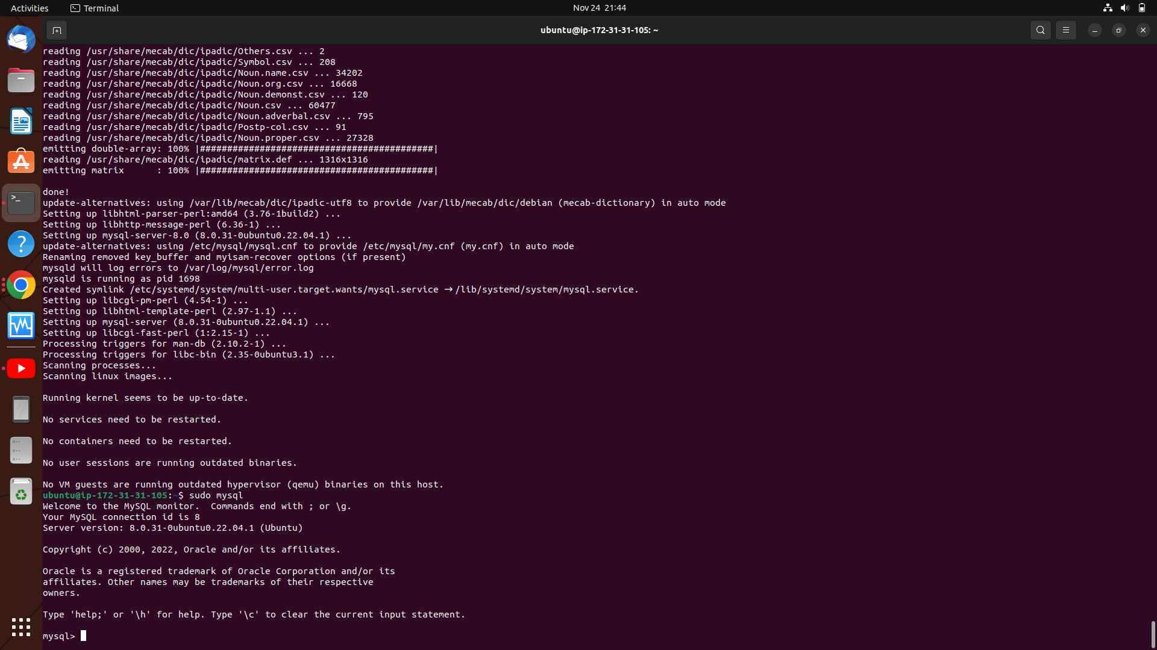

Then I changed the root password and some settings

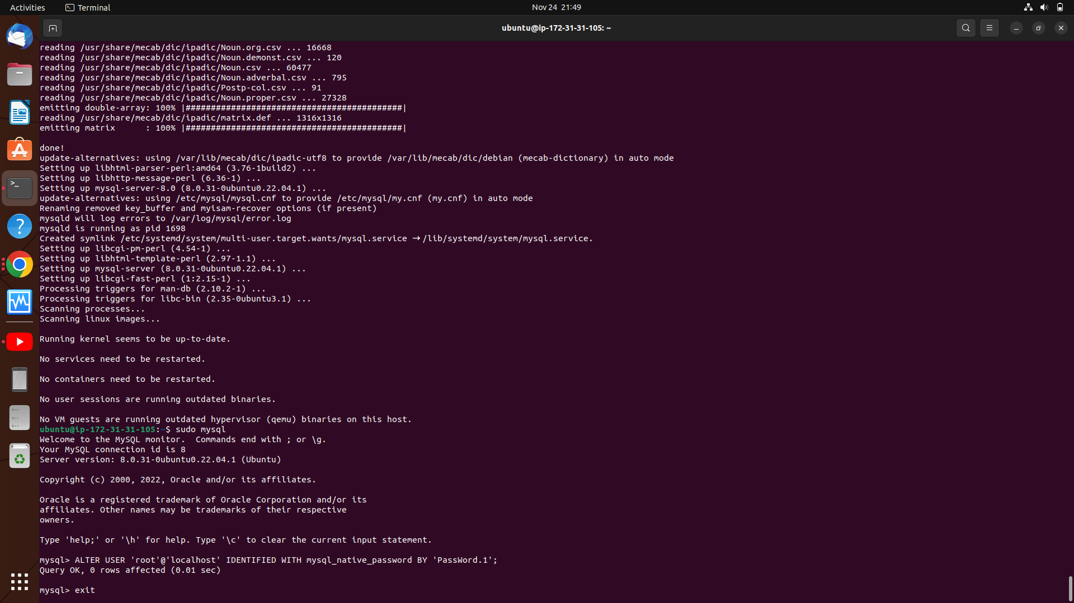

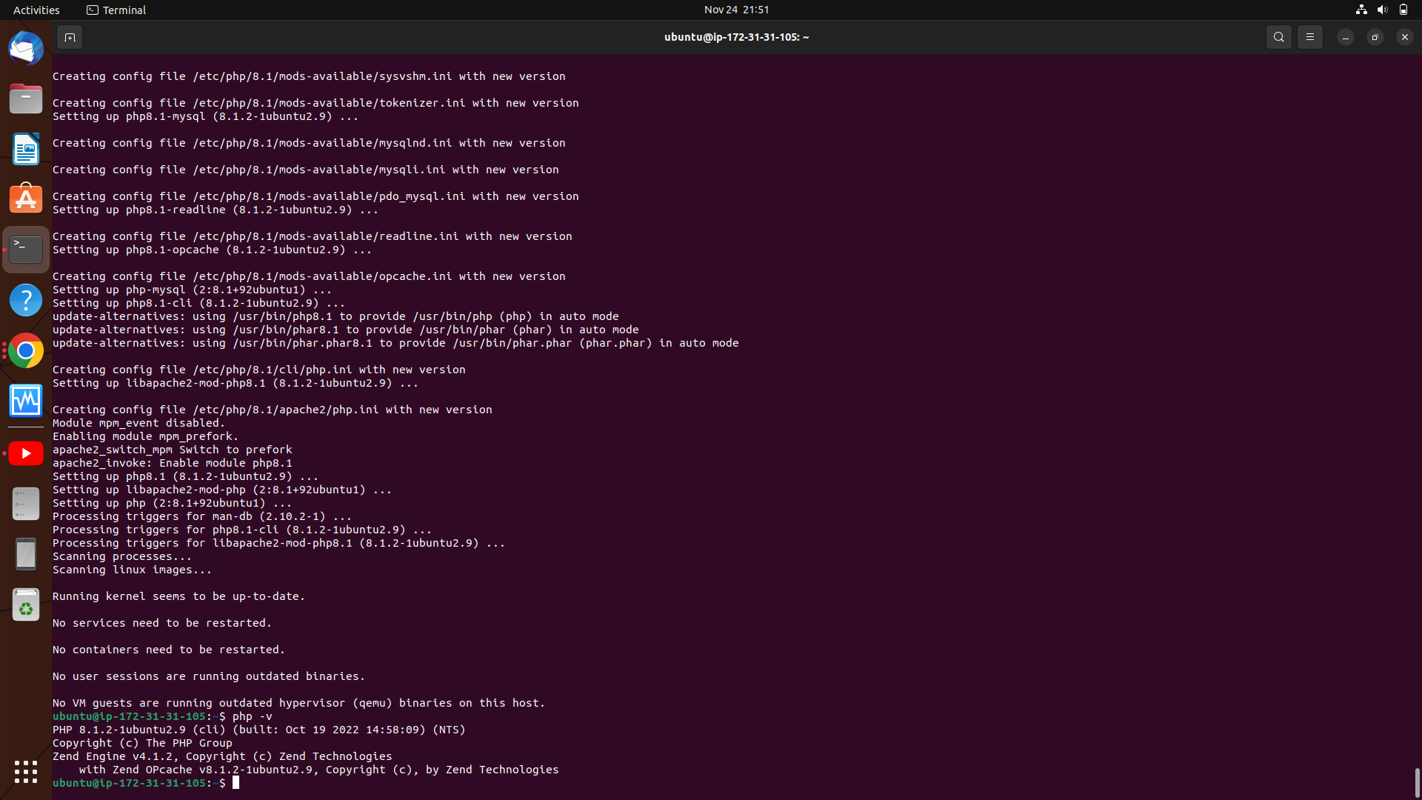
After that, I installed the PHP server
I then confimred the PHP installation by checking the PHP version

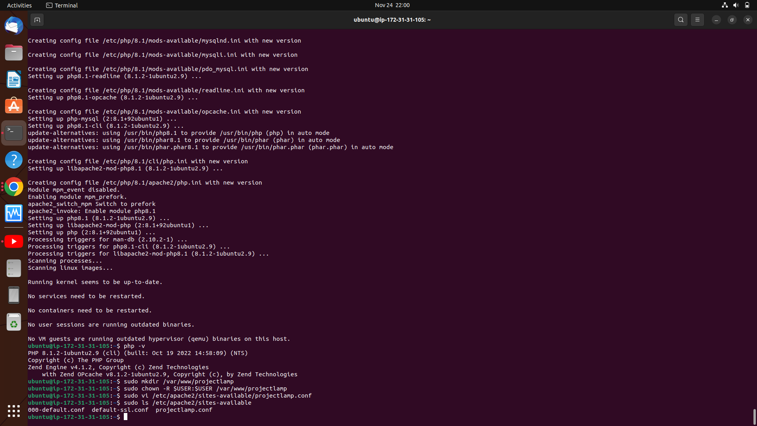

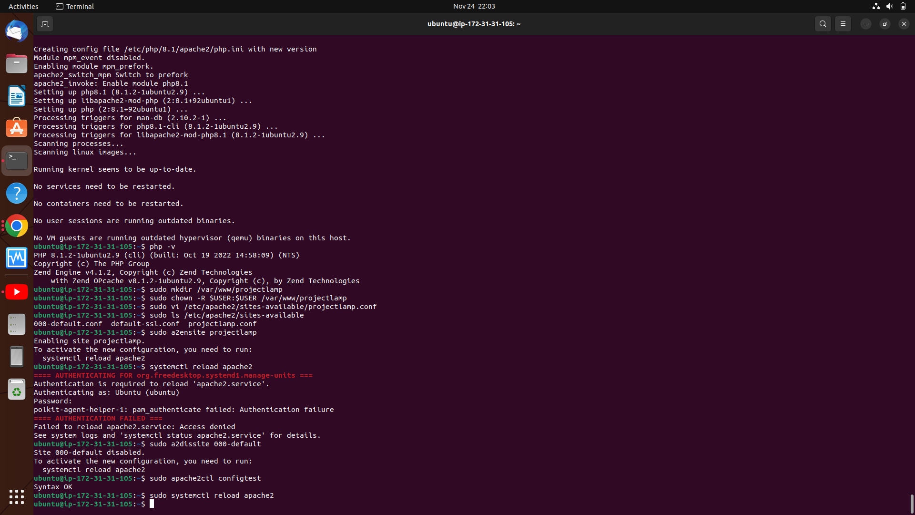
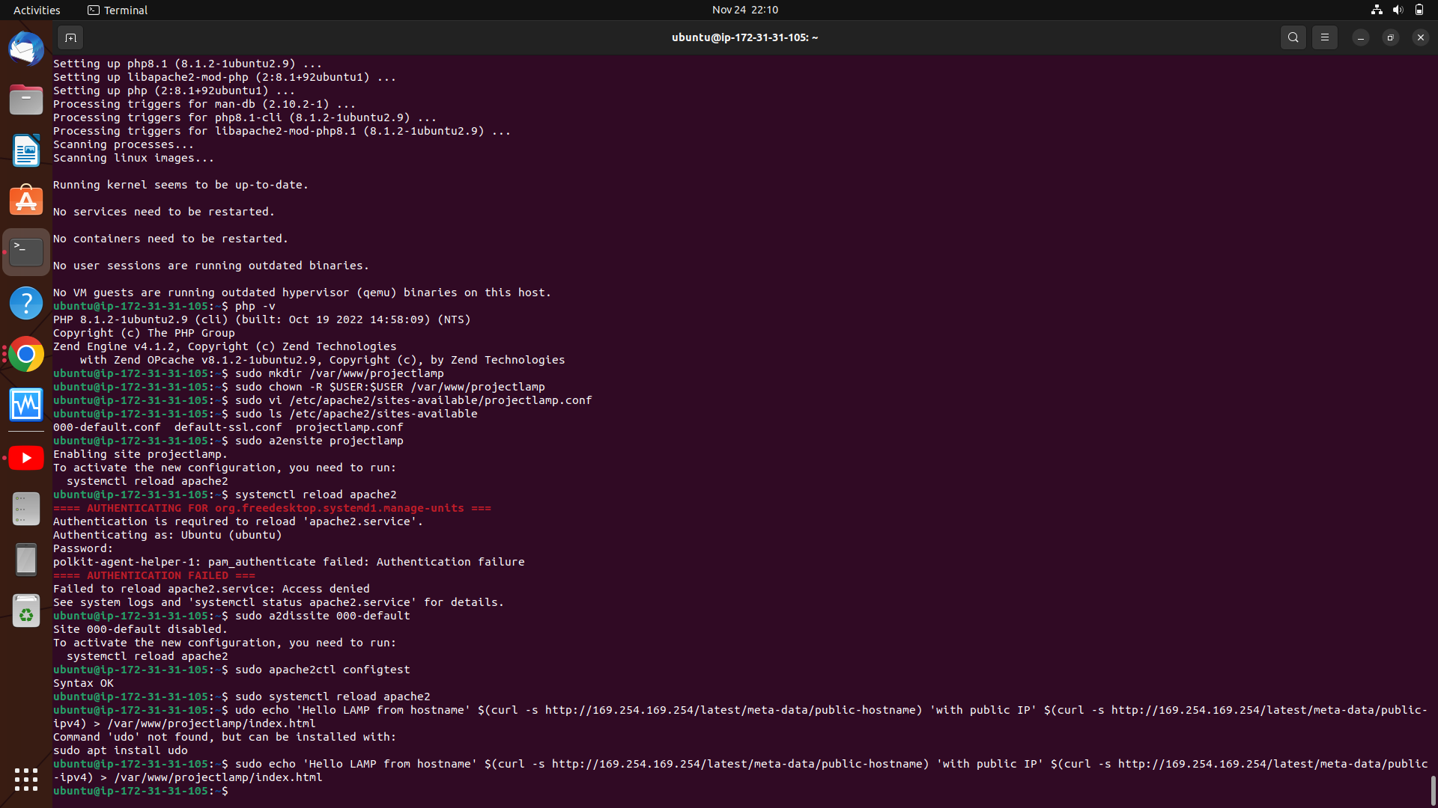
I confired the Apache webserver is running by going to my public IP’s port 80 which is the http port

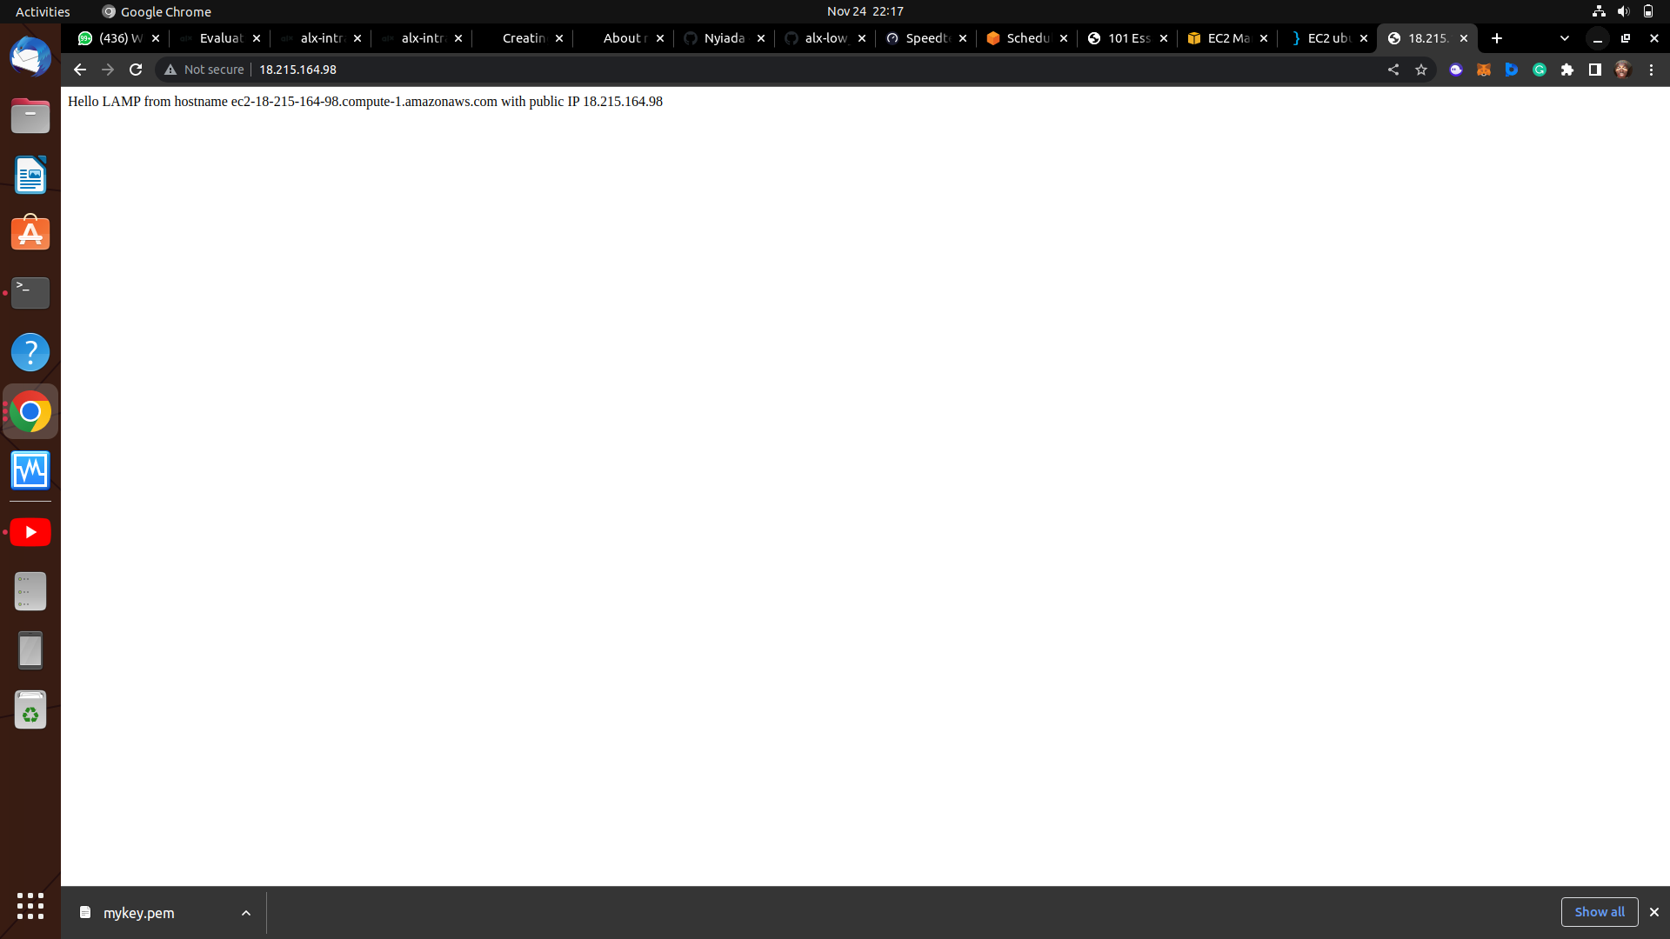

I editted the /etc/apache2/mods-enabled/dir.conf file to direct it to the php server

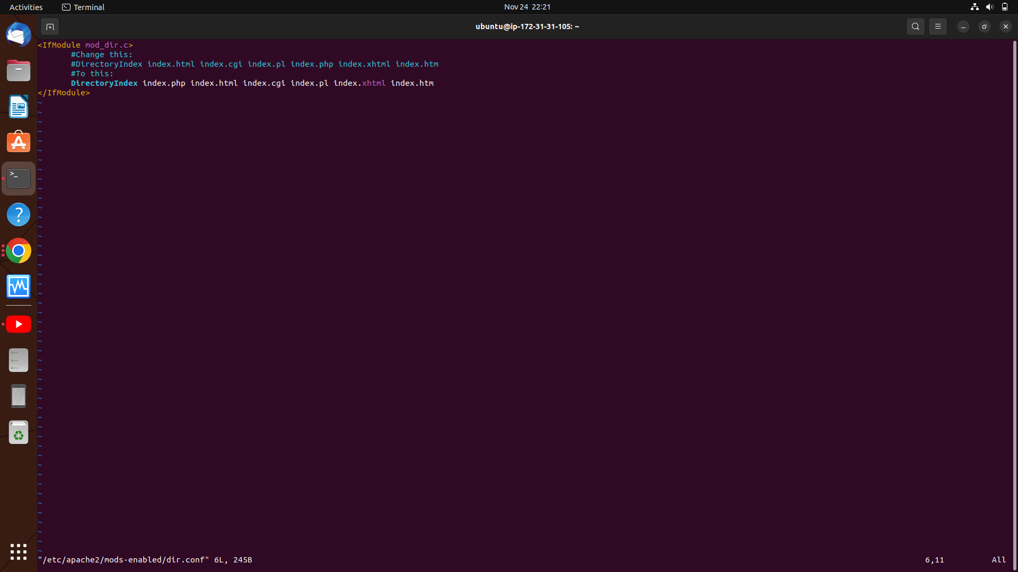

When going to the public IP’s port 80 now, it shows the php info page

